
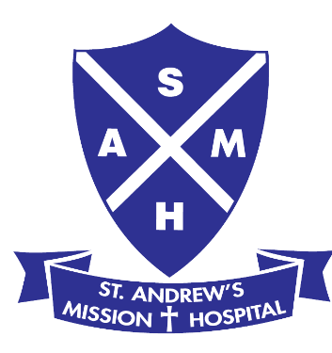
DONATION FORM (Cash / Cheque / Credit Card)

I / We wish to support your work and make a donation to: (Select one or more services below)

St. Andrew’s Mission Hospital: | Singapore Anglican Community Services:
□ St. Andrew’s Nursing Home (Buangkok) | □ St. Andrew’s Nursing Home (Taman Jurong)
□ St. Andrew’s Nursing Home (Henderson)
□ St. Andrew’s Nursing Home (Queenstown)

By Cash¹: Amount: S$ Date:

Received by: Verified by:

By Cheque²: Bank and Cheque no.: Amount: S$
Please issue your cheque to St. Andrew’s Mission Hospital or Singapore Anglican Community Services (whichever is applicable). On the back of the cheque, indicate the name of the specific nursing home (as selected above), your full name, NRIC/FIN No. (for corporate donations, your company name & UEN no.) and contact number.

By Credit Card²:
□ one-time donation □ monthly donation, from ___________ (month/year) to __________ (month/year)

Credit Card no.: ______________________________________________ (Visa / MasterCard / AMEX)

Amount: S$___________ Name of Bank: ______________________ Card expiry date: __________

Signature: Date:

Donations of $50 and above are eligible for tax deduction. From 1 January 2011, IRAS will no longer accept claims for tax deduction based on donation receipts. Tax deductions for the donations will be automatically reflected in your tax assessments based on the information from the Institute of Public Character (IPC), i.e., the Charity.

All donors who give S$1000 or more will be acknowledged in the St. Andrew’s Mission Hospital / Annual Report, unless otherwise indicated, below.

To St. Andrew’s Nursing Home:
□ I do not want any tax deduction.
□ I do not want any receipt
□ I do not wish to be acknowledged in the St. Andrew’s Mission Hospital / Singapore Anglican Community Services Annual Report.

Donor’s Particulars (for tax exemption purpose and/or mailing of receipts):

Dr./ Mr./ Mrs./ Miss/ Mdm./ Ms./ _____________

Name of Person or Company (in full): _

NRIC / FIN / ROB / ROC / UEN No.: _

Mailing address: _____

Contact details: ___________________________ (email) ________________ (H/P) _______________ (H)

¹ Cash donation: Please visit your selected service and submit this form together with your donation.
² Cheque or credit card donation: (1) Please visit your selected service and submit this form (and cheque, if any) or
(2) Please post this form (and cheque, if any) to: (whichever is applicable) St. Andrew’s Mission Hospital, Admin Department, 10 Simei Street 3, S 529895 or Singapore Anglican Community Services, Fund Raising Department, 10 Simei Street 3, S 529897.
Thank you for your donation and support!

